Testing Addition of Smaller refinement curves to large element

Wednesday, January 17, 2018

3:36 PM

One of the problems with generating the penetration region curves is that they are at a much higher refinement than the mesh they are being added to. The first order of business is to determine how much an effect these curves will have on the analysis. When meshing these curve points, high aspect ratio element could be a problem. Therefore, this is the scenario being analyzed.

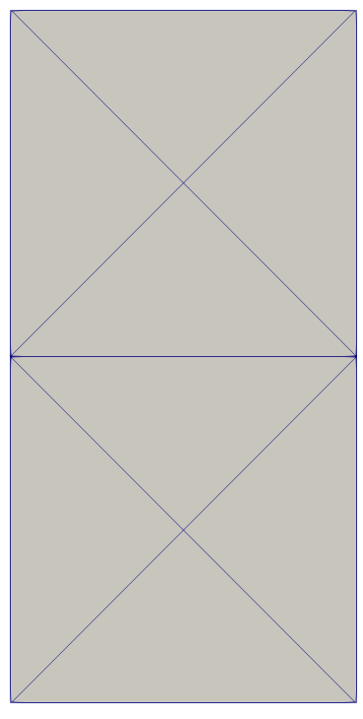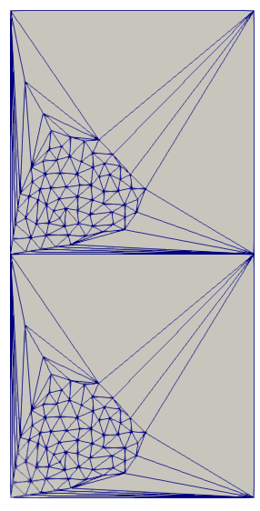

Screen clipping taken: 1/17/2018 3:43 PM

|  |  |  |  |  |
| --- | --- | --- | --- | --- |
| Original mesh |  |  |  | Mesh with curve points added |

The mirroring of the mesh is so that the upper and lower sections can be applied a different material property to enforce a stress gradient over the mesh. The upper portions has a Youngs modulus that is one magnitude lower that the bottom portion (1e8, 1e9)

Now the direct solver approach had no difference between the simple and complex meshes. Therefore, we decided to analyze an iterative method (conjugate gradient) and compare it to the direct solver method for just the complex mesh. Results below.

StressGIobaI Magnitude 
StressGIobaI Magnitude 

**The left is with the conjugate gradient, the right is the direct solver method**. The first thing to notice is that both meshes are on the same stress contour scale. One thing that stands out is the much smoother gradients of stress with the direct solver method vs. the conjugate gradient method. Also, the direct method does not appear to reach the bottom of the stress scale. Generally speaking the contour scale does not even spread an order of magnitude so the difference qualitatively is not very high.

The bottom left node highlighted on the left mesh has the stress values -1.026e+6        2.13374e+6        32727.8.

The same node on the right mesh has the values -867761        1.84309e+6        -148071.

We can see that the values are within an order of magnitude of each other (disregarding the z-direction).

For the bottom right node on the left is -205601         3.51536e+6        18223.6

For the same node on the right mesh -61657.3        3.15319e+6        148221

The y direction stresses are very close however the x direction is not so close.